Image | 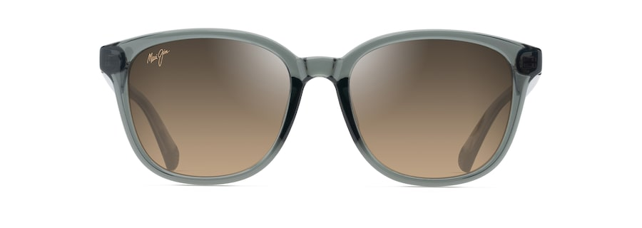
Brand | MAUI JIM
Model Name | KU‘IKAHI ASIAN FIT
Price | RS 3490
PRODUCT DETAILS

